THE MULTI-CAVITY KLYSTRON AMPLIFIERS
Klystron amplification, power output, and efficiency can be greatly improved by the addition of intermediate cavities between the input and output cavities of the basic klystron. Additional cavities serve to velocity-modulate the electron beam and produce an increase in the energy available at the output. Since all intermediate cavities in a multicavity klystron operate in the same manner, a representative three-cavity klystron will be discussed as a representative of the rest.
A three-cavity klystron is illustrated in Fig. 1. The entire drift-tube assembly, the three cavities, and the collector plate of the three-cavity klystron are operated at ground potential for reasons of safety. The electron beam is formed and accelerated toward the drift tube by a large negative pulse applied to the cathode. Magnetic focus coils are placed around the drift tube to keep the electrons in a tight beam and away from the side walls of the tube. The focus of the beam is also aided by the concave shape of the cathode in high-powered klystrons.
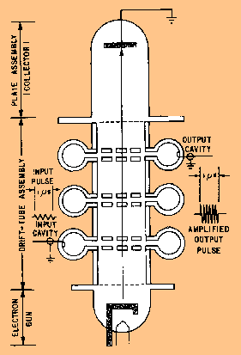
Fig. 1. - Three-cavity klystron.
The output of any klystron (regardless of the number of cavities used) is developed by velocity modulation of the electron beam. The electrons that are accelerated by the cathode pulse are acted upon by rf fields developed across the input and middle cavities. Some electrons are accelerated, some are decelerated, and some are unaffected. Electron reaction depends on the amplitude and polarity of the fields across the cavities when the electrons pass the cavity gaps. During the time the electrons are traveling through the drift space between the cavities, the accelerated electrons overtake the decelerated electrons to form bunches. As a result, bunches of electrons arrive at the output cavity at the proper instant during each cycle of the rf field and deliver energy to the output cavity.
Only a small degree of bunching takes place within the electron beam during the interval of travel from the input cavity to the middle cavity. The amount of bunching is sufficient, however, to cause oscillations within the middle cavity and to maintain a large oscillating voltage across the input gap. Most of the velocity modulation produced in the three-cavity klystron is caused by the voltage across the input gap of the middle cavity. The high voltage across the gap causes the bunching process to proceed rapidly in the drift space between the middle cavity and the output cavity. The electron bunches cross the gap of the output cavity when the gap voltage is at maximum negative. Maximum energy transfer from the electron beam to the output cavity occurs under these conditions. The energy given up by the electrons is the kinetic energy that was originally absorbed from the cathode pulse.
Klystron amplifiers have been built with as many as five intermediate cavities in addition to the input and output cavities. The effect of the intermediate cavities is to improve the electron bunching process which improves amplifier gain. The overall efficiency of the tube is also improved to a lesser extent. Adding more cavities is roughly the same as adding more stages to a conventional amplifier. The overall amplifier gain is increased and the overall bandwidth is reduced if all the stages are tuned to the same frequency. The same effect occurs with multicavity klystron tuning. A klystron amplifier tube will deliver high gain and a narrow bandwidth if all the cavities are tuned to the same frequency. This method of tuning is called synchronous tuning. If the cavities are tuned to slightly different frequencies, the gain of the amplifier will be reduced but the bandwidth will be appreciably increased. This method of tuning is called staggered tuning.
REVIEW QUESTIONS AND ANSWERS
Q.1 What can be added to the basic two-cavity klystron to increase the amount of velocity modulation and the power output?
A1. Intermediate cavities between the input and output cavities.
Q.2 How is the electron beam of a three-cavity klystron accelerated toward the drift tube?
A2. A large negative pulse is applied to the cathode.
Q.3 Which cavity of a three-cavity klystron causes most of the velocity modulation?
A3. The middle cavity.
Q.4 In a multicavity klystron, tuning all the cavities to the same frequency has what effect on the bandwidth of the tube?
A4. The bandwidth decreases.
Q.5 The cavities of a multicavity klystron are tuned to slightly different frequencies in what method of tuning?
A5. Stagger tuning.

THE REFLEX KLYSTRON
The reflex klystron contains a reflector plate, referred to as the repeller, instead of the output cavity used in other types of klystrons. The electron beam is modulated as it was in the other types of klystrons by passing it through an oscillating resonant cavity, but here the similarity ends. The feedback required to maintain oscillations within the cavity is obtained by reversing the beam and sending it back through the cavity. The electrons in the beam are velocity-modulated before the beam passes through the cavity the second time and will give up the energy required to maintain oscillations. The electron beam is turned around by a negatively charged electrode that repels the beam. This negative element is the repeller mentioned earlier. This type of klystron oscillator is called a reflex klystron because of the reflex action of the electron beam.
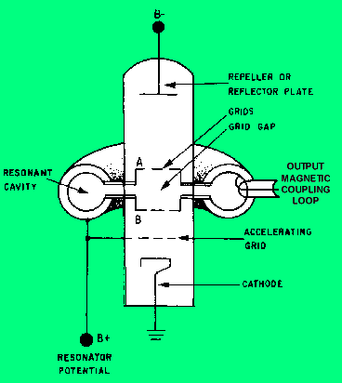
Figure 1. Functional diagram of a reflex klystron.

Three power sources are required for reflex klystron operation: (1) filament power, (2) positive resonator voltage (often referred to as beam voltage) used to accelerate the electrons through the grid gap of the resonant cavity, and (3) negative repeller voltage used to turn the electron beam around. The electrons are focused into a beam by the electrostatic fields set up by the resonator potential (B+) in the body of the tube. Note in figure 1 that the resonator potential is common to the resonator cavity, the accelerating grid, and the entire body of the tube.
The resonator potential also causes the resonant cavity to begin oscillating at its natural frequency when the tube is energized. These oscillations cause an electrostatic field across the grid gap of the cavity that changes direction at the frequency of the cavity. The changing electrostatic field affects the electrons in the beam as they pass through the grid gap. Some are accelerated and some are decelerated, depending upon the polarity of the electrostatic field as they pass through the gap. Figure 2, view (A), illustrates the three possible ways an electron can be affected as it passes through the gap (velocity increasing, decreasing, or remaining constant). Since the resonant cavity is oscillating, the grid potential is an alternating voltage that causes the electrostatic field between the grids to follow a sine-wave curve as shown in figure 2-10, view (B). As a result, the velocity of the electrons passing through the gap is affected uniformly as a function of that sine wave. The amount of velocity change is dependent on the strength and polarity of the grid voltage.
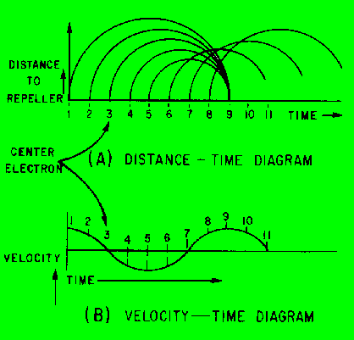
Figure 2. Electron bunching diagram.

The variation in grid voltage causes the electrons to enter the space between the grid and the repeller at various velocities. For example, in figure 2-10, views (A) and (B), the electrons at times 1 and 2 are speeded up as they pass through the grid. At time 3, the field is passing through zero and the electron is unaffected. At times 4 and 5, the grid field is reversed; the electrons give up energy because their velocity is reduced as they pass through the grids.
The distance the electrons travel in the space separating the grid and the repeller depends upon their velocity. Those moving at slower velocities, such as the electron at time 4, move only a short distance from the grid before being affected by the repeller voltage. When this happens, the electron is forced by the repeller voltage to stop, reverse direction, and return toward the grid. The electrons moving at higher velocities travel further beyond the grid before reversing direction because they have greater momentum. If the repeller voltage is set at the correct value, the electrons will form a bunch around the constant-speed electrons. The electrons will then return to the grid gap at the instant the electrostatic field is at the correct polarity to cause maximum deceleration of the bunch. This action is also illustrated in figure 2, view (A). When the grid field provides maximum deceleration, the returning electrons release maximum energy to the grid field which is in phase with cavity current. Thus, the returning electrons supply the regenerative feedback required to maintain cavity oscillations.
The constant-speed electrons must remain in the reflecting field space for a minimum time of 3/4 cycle of the grid field for maximum energy transfer. The period of time the electrons remain in the repeller field is determined by the amount of negative repeller voltage. The reflex klystron will continue to oscillate if the electrons remain in the repeller field longer than 3/4 cycle (as long as the electrons return to the grid gap when the field is of the proper polarity to decelerate the electrons).
Figure 3 shows the effect of the repeller field on the electron bunch for 3/4 cycle and for 1 3/4 cycles. This figure is reffered to as the Apple Gate Diagram. Although not shown in the figure, the constant-velocity electrons may remain in the repeller field for any number of cycles over the minimum 3/4 cycle. If the electrons remain in the field for longer than 3/4 cycle, the difference in electron transit time causes the tube performance characteristics to change. The differences in operating characteristics are identified by modes of operation.
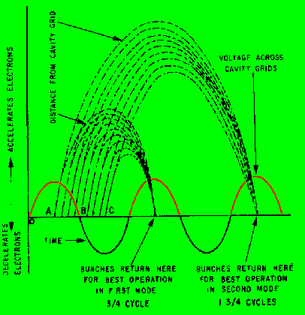
Figure 3. - Bunching action of a reflex klystron.

The reflex klystron operates in a different mode for each additional cycle that the electrons remain in the repeller field. Mode 1 is obtained when the repeller voltage produces an electron transit time of 3/4 cycle. Additional modes follow in sequence. Mode 2 has an electron transit time of 1 3/4 cycles; mode 3 has an electron transit time of 2 3/4 cycles; etc. The physical design of the tube limits the number of modes possible in practical applications. A range of four modes of operation are normally available. The actual mode used (1 3/4 cycles through 4 3/4 cycles, 2 3/4 cycles through 6 3/4 cycles, etc.) depends upon the application. The choice of mode is determined by the difference in power available from each mode and the band of frequencies over which the circuit can be tuned.
OUTPUT POWER.
The variation in output power for different modes of operation can be explained by examining the factors which limit the amplitude of oscillations. Power and amplitude limitations are caused by the debunching process of the electrons in the repeller field space. Debunching is simply the spreading out of the electron bunches before they reach electrostatic fields across the cavity grid . The lower concentration of electrons in the returning bunches provides less power for delivery to the oscillating cavity. This reduced power from the bunches, in turn, reduces the amplitude of the cavity oscillations and causes a decrease in output power. In higher modes of operation the electron bunches are formed more slowly. They are more likely to be affected by debunching because of mutual repulsion between the negatively charged electrons. The long drift time in the higher modes allows more time for this electron interaction and, as a result, the effects of debunching are more severe. The mutual repulsion changes the relative velocity between the electrons in the bunches and causes the bunches to spread out.
Figure 4 illustrates the electronic tuning (tuning by altering the repeller voltage) range and output power of a reflex klystron. Each mode has a center frequency of 3,000 megahertz which is predetermined by the physical size of the cavity. The output power increases as the repeller voltage is made more negative. This is because the transit time of the electron bunches is decreased. 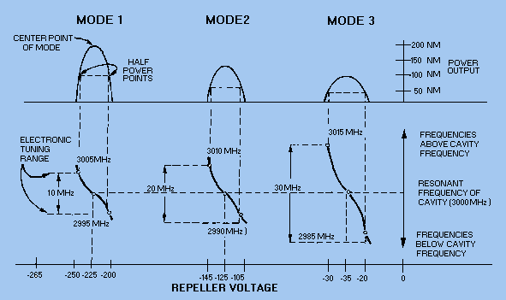
Figure 4. Electronic tuning and output power of a reflex klystron.

Electronic tuning does not change the center frequency of the cavity, but does vary the frequency within the mode of operation. The amount the frequency can be varied above or below the center frequency is limited by the half-power points of the mode, as shown in figure 4. The center frequency can be changed by one of two methods One method, grid-gap tuning, varies the cavity frequency by altering the distance between the grids to change the physical size of the cavity. This method varies the capacitance of the cavity by using a tuning screw to change the distance between the grids mechanically. The cavity can also be tuned by PADDLES or SLUGS that change the inductance of the cavity.
REVIEW QUESTIONS AND ANSWERS
Q.20 What element of the reflex klystron replaces the output cavity of a normal klystron?
A20. The reflector or repeller.
Q.21 When the repeller potential is constant, what property of the electron determines how long it will remain in the drift space of the reflex klystron?
A21. Velocity.
Q.22 The constant-speed electrons of an electron bunch in a reflex klystron must remain in the repeller field for what minimum time?
A22. Three-quarter cycle.
Q.23 If the constant-speed electrons in a reflex klystron remain in the repeller field for 1 3/4 cycles, what is the mode of operation?
A23. Mode 2.
Q.24 Debunching of the electron bunches in the higher modes of a reflex klystron has what effect on output power?
A24. Power is reduced.
Q.25 What limits the tuning range around the center frequency of a reflex klystron in a particular mode of operation?
A25. The half-power points of the mode.

THE MAGNETRON
The magnetron, shown in Figure 1, view (A), is a self-contained microwave oscillator that operates differently from the linear-beam tubes, such as the TWT and the klystron. View (B) is a simplified drawing of the magnetron. crossed-electron and magnetic fields are used in the magnetron to produce the high-power output required in radar and communications equipment.
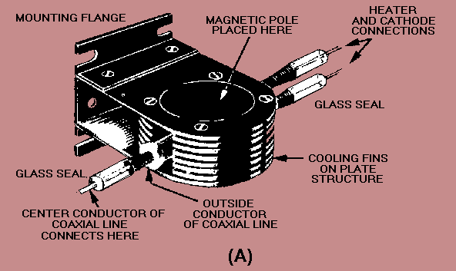
Figure 1. - Magnetron.
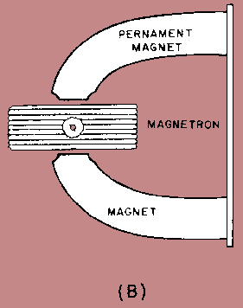
The magnetron is classified as a diode because it has no grid. A magnetic field located in the space between the plate (anode) and the cathode serves as a grid. The plate of a magnetron does not have the same physical appearance as the plate of an ordinary electron tube. Since conventional inductive-capacitive (LC) networks become impractical at microwave frequencies, the plate is fabricated into a cylindrical copper block containing resonant cavities which serve as tuned circuits. The magnetron base differs considerably from the conventional tube base. The magnetron base is short in length and has large diameter leads that are carefully sealed into the tube and shielded.
The cathode and filament are at the center of the tube and are supported by the filament leads. The filament leads are large and rigid enough to keep the cathode and filament structure fixed in position. The output lead is usually a probe or loop extending into one of the tuned cavities and coupled into a waveguide or coaxial line. The plate structure, shown in Figure 2, is a solid block of copper. The cylindrical holes around its circumference are resonant cavities. A narrow slot runs from each cavity into the central portion of the tube dividing the inner structure into as many segments as there are cavities. Alternate segments are strapped together to put the cavities in parallel with regard to the output. The cavities control the output frequency. The straps are circular, metal bands that are placed across the top of the block at the entrance slots to the cavities. Since the cathode must operate at high power, it must be fairly large and must also be able to withstand high operating temperatures. It must also have good emission characteristics, particularly under return bombardment by the electrons. This is because most of the output power is provided by the large number of electrons that are emitted when high-velocity electrons return to strike the cathode. The cathode is indirectly heated and is constructed of a high-emission material. The open space between the plate and the cathode is called the interaction space. In this space the electric and magnetic fields interact to exert force upon the electrons.
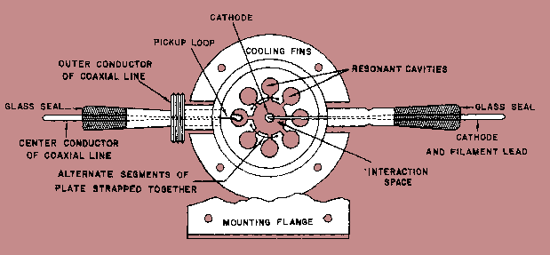
Figure 2. Cutaway view of a magnetron.

The magnetic field is usually provided by a strong, permanent magnet mounted around the magnetron so that the magnetic field is parallel with the axis of the cathode. The cathode is mounted in the center of the interaction space.
BASIC MAGNETRON OPERATION
Magnetron theory of operation is based on the motion of electrons under the influence of combined electric and magnetic fields. The following information presents the laws governing this motion.
The direction of an electric field is from the positive electrode to the negative electrode. The law governing the motion of an electron in an electric field (E field) states:
The force exerted by an electric field on an electron is proportional to the strength of the field. Electrons tend to move from a point of negative potential toward a positive potential.
This is shown in Figure 3. In other words, electrons tend to move against the E field. When an electron is being accelerated by an E field, as shown in figure 3, energy is taken from the field by the electron.
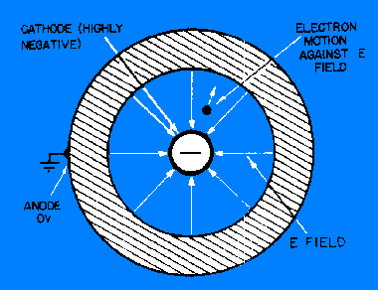
Figure 3. - Electron motion in an electric field.

The law of motion of an electron in a magnetic field (H field) states:
The force exerted on an electron in a magnetic field is at right angles to both the field and the path of the electron. The direction of the force is such that the electron trajectories are clockwise when viewed in the direction of the magnetic field.
This is shown in figure 4.
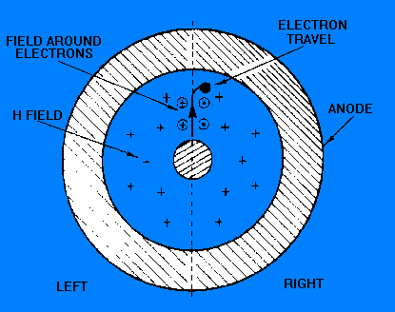
Figure 4. Electron motion in a magnetic field.

In figure 4, assume that a south pole is below the figure and a north pole is above the figure so that the magnetic field is going into the paper. When an electron is moving through space, a magnetic field builds around the electron just as it would around a wire when electrons are flowing through a wire. The magnetic field around the moving electron adds to the permanent magnetic field on the left side of the electron's path and subtracts from the permanent magnetic field on the right side. This action weakens the field on the right side; therefore, the electron path bends to the right (clockwise). If the strength of the magnetic field is increased, the path of the electron will have a sharper bend. Likewise, if the velocity of the electron increases, the field around it increases and the path will bend more sharply.
A schematic diagram of a basic magnetron is shown in Figure 5, view (A). The tube consists of a cylindrical plate with a cathode placed along the center axis of the plate. The tuned circuit is made up of cavities in which oscillations take place and are physically located in the plate.
When no magnetic field exists, heating the cathode results in a uniform and direct movement of the field from the cathode to the plate, as illustrated in figure 5, view (B). However, as the magnetic field surrounding the tube is increased, a single electron is affected, as shown in figure 6. In view (A), the magnetic field has been increased to a point where the electron proceeds to the plate in a curve rather than a direct path.
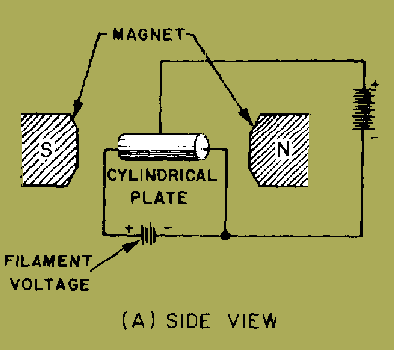
(a) Basic magnetron. End view omitting magnets
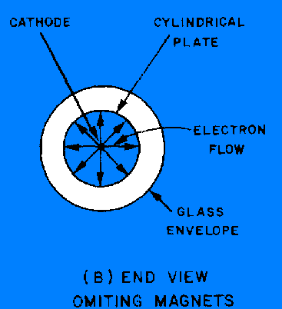
(b) Effect of a magnetic field on a single electron
Figure 5. A schematic diagram of a basic magnetron
In view (B) of figure 5, the magnetic field has reached a value great enough to cause the electron to just miss the plate and return to the filament in a circular orbit. This value is the CRITICAL VALUE of field strength. In view (C), the value of the field strength has been increased to a point beyond the critical value; the electron is made to travel to the cathode in a circular path of smaller diameter.
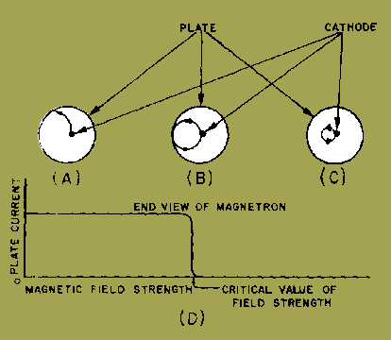
Figure 6. Effect of a magnetic field on a single electron
View (D) of figure 6. shows how the magnetron plate current varies under the influence of the varying magnetic field. In view (A), the electron flow reaches the plate, so a large amount of plate current is flowing. However, when the critical field value is reached, as shown in view (B), the electrons are deflected away from the plate and the plate current then drops quickly to a very small value. When the field strength is made still greater, as shown in view (C), the plate current drops to zero.
When the magnetron is adjusted to the cutoff, or critical value of the plate current, and the electrons just fail to reach the plate in their circular motion, it can produce oscillations at microwave frequencies. These oscillations are caused by the currents induced electrostatically by the moving electrons. The frequency is determined by the time it takes the electrons to travel from the cathode toward the plate and back again. A transfer of microwave energy to a load is made possible by connecting an external circuit between the cathode and the plate of the magnetron. Magnetron oscillators are divided into two classes (a) negative-resistance and (b) electron-resonance magnetron oscillators.
- A negative-resistance magnetron oscillator is operated by a static negative resistance between its electrodes. This oscillator has a frequency equal to the frequency of the tuned circuit connected to the tube.
(b) An electron-resonance magnetron oscillator is operated by the electron transit time required for electrons to travel from cathode to plate. This oscillator is capable of generating very large peak power outputs at frequencies in the thousands of megahertz. Although its average power output over a period of time is low, it can provide very high-powered oscillations in short bursts of pulses.

- MECHANISM OF OSCILLATION IN MAGNETRON ( ∏ mode of Oscillation)
  - It is understood that the oscillation are capable of starting a device because of high quality factor.
Q=fc/BW(For oscillator BW→0,Hence Q→∞)
The self oscillation can be maintained if the phase dissimilarity between anode cavity is N∏/4 and the best result can be obtained for N=4.
Hence,it is called ‘∏’ mode oscillation

REVIEW QUESTIONS AND ANSWERS
Q.31 The folded waveguide in a BWO serves the same purpose as what component in a twt?
A31. Helix.
Q.32 What serves as a grid in a magnetron?
A32. A magnetic field.
Q.33. A cylindrical copper block with resonant cavities around the circumference is used as what component of a magnetron?
A33. Anode or plate.
Q.34 What controls the output frequency of a magnetron?
A34. The resonant cavities.
Q.35 What element in the magnetron causes the curved path of electron flow?
A35. The permanent magnet.
Q.36 What is the term used to identify the amount of field strength required to cause the electrons to just miss the plate and return to the filament in a circular orbit?
A36. The critical value of field strength.
Q.37. A magnetron will produce oscillations when the electrons follow what type of path?
A37. Circular.

NEGATIVE-RESISTANCE MAGNETRON.
The split-anode, negative-resistance magnetron is a variation of the basic magnetron which operates at a higher frequency. The negative-resistance magnetron is capable of greater power output than the basic magnetron. Its general construction is similar to the basic magnetron except that it has a split plate, as shown in Figure 1.
These half plates are operated at different potentials to provide an electron motion, as shown in Figure 2. The electron leaving the cathode and progressing toward the high-potential plate is deflected by the magnetic field and follows the path shown in figure 2. After passing the split between the two plates, the electron enters the electrostatic field set up by the lower-potential plate.
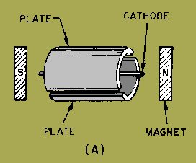
Figure 1(a). Split-anode magnetron.
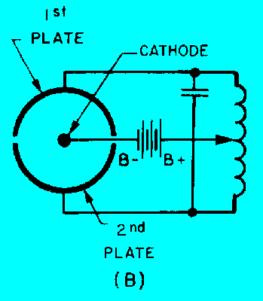
Figure 1(b). Electric circuit Split-anode magnetron

Figure 2-24. - Movement of an electron in a split-anode magnetron.

Here the magnetic field has more effect on the electron and deflects it into a tighter curve. The electron then continues to make a series of loops through the magnetic field and the electric field until it finally arrives at the low-potential plate.
Oscillations are started by applying the proper magnetic field to the tube. The field value required is slightly higher than the critical value. In the split-anode tube, the critical value is the field value required to cause all the electrons to miss the plate when its halves are operating at the same potential. The alternating voltages impressed on the plates by the oscillations generated in the tank circuit will cause electron motion, such as that shown in figure 2-24, and current will flow. Since a very concentrated magnetic field is required for the negative-resistance magnetron oscillator, the length of the tube plate is limited to a few centimeters to keep the magnet at reasonable dimensions. In addition, a small diameter tube is required to make the magnetron operate efficiently at microwave frequencies. A heavy-walled plate is used to increase the radiating properties of the tube. Artificial cooling methods, such as forced-air or water-cooled systems, are used to obtain still greater dissipation in these high-output tubes.

The output of a magnetron is reduced by the bombardment of the filament by electrons which travel in loops. This action causes an increase of filament temperature under conditions of a strong magnetic field and high plate voltage and sometimes results in unstable operation of the tube. The effects of filament bombardment can be reduced by operating the filament at a reduced voltage. In some cases, the plate voltage and field strength are also reduced to prevent destructive filament bombardment.
ELECTRON-RESONANCE MAGNETRON
In the electron-resonance magnetron, the plate is constructed to resonate and function as a tank circuit. Thus, the magnetron has no external tuned circuits. Power is delivered directly from the tube through transmission lines, as shown in figure 3. The constants and operating conditions of the tube are such that the electron paths are somewhat different from those in figure 2-24. Instead of closed spirals or loops, the path is a curve having a series of sharp points, as illustrated in figure 4. Ordinarily, this type of magnetron has more than two segments in the plate. For example, figure 4 illustrates an eight-segment plate.
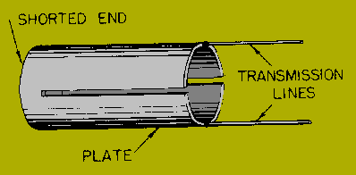
Figure 3. Plate tank circuit of a magnetron.
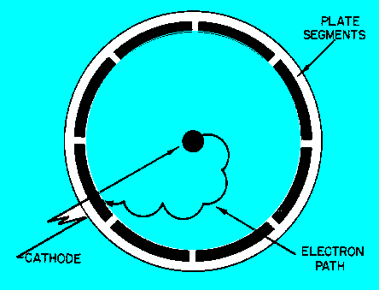
Figure 4. Electron path in an electron-resonance magnetron.

The electron-resonance magnetron is the most widely used for microwave frequencies because it has reasonably high efficiency and relatively high output. The average power of the electron-resonance magnetron is limited by the amount of cathode emission, and the peak power is limited by the maximum voltage rating of the tube components. Three common types of anode blocks used in electron-resonance magnetrons are shown in figure 5.
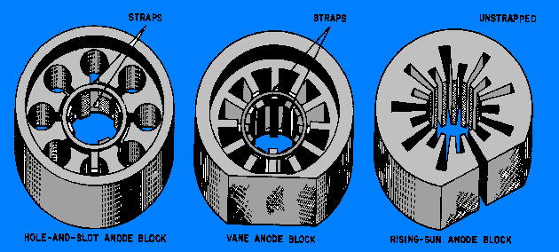
Figure 5. - Common types of anode blocks.

The anode block shown in figure 5, view (A), has cylindrical cavities and is called a HOLE-AND-SLOT ANODE. The anode block in view (B) is called the VANE ANODE which has trapezoidal cavities. The first two anode blocks operate in such a way that alternate segments must be connected, or strapped, so that each segment is opposite in polarity to the segment on either side, as shown in figure 7. This also requires an even number of cavities.
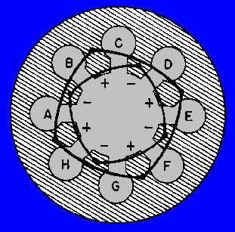
Figure 7. - Strapping alternate segments.

The anode block illustrated in figure 5, view (C), is called a RISING-SUN BLOCK. The alternate large and small trapezoidal cavities in this block result in a stable frequency between the resonant frequencies of the large and small cavities.
Figure 8, view (A), shows the physical relationships of the resonant cavities contained in the hole-and-slot anode (figure 5, view (A)). This will be used when analyzing the operation of the electron-resonance magnetron.
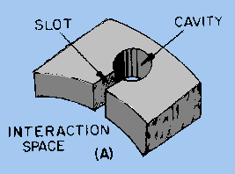
Figure 8. Equivalent circuit of a hole-and-slot cavity.

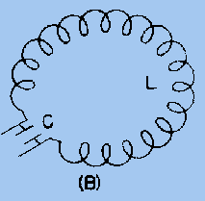
Figure 9. Equivalent circuit of a hole-and-slot cavity.

COUPLING METHODS
Energy (rf) can be removed from a magnetron by means of a coupling loop. At frequencies lower than 10 GHz, the coupling loop is made by bending the inner conductor of a coaxial cable into a loop. The loop is then soldered to the end of the outer conductor so that it projects into the cavity, as shown in figure 1, view (A). Locating the loop at the end of the cavity, as shown in view (B), causes the magnetron to obtain sufficient pickup at higher frequencies.
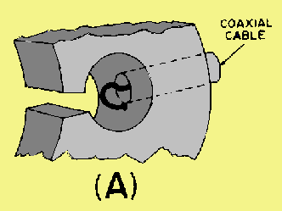

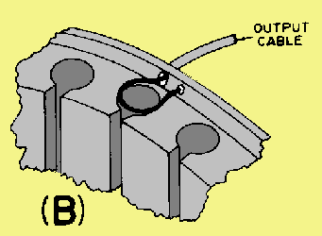
Figure 1. - Magnetron coupling methods.

The segment-fed loop method is shown in view (C) of figure 2-35. The loop intercepts the magnetic lines passing between cavities. The strap-fed loop method (view (D), intercepts the energy between the strap and the segment. On the output side, the coaxial line feeds another coaxial line directly or feeds a waveguide through a choke joint. The vacuum seal at the inner conductor helps to support the line. Aperture, or slot, coupling is illustrated in view (E). Energy is coupled directly to a waveguide through an iris.
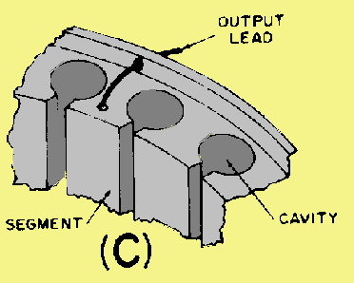
Segment-fed loop method - loop intercepts the magnetic lines passing between cavities
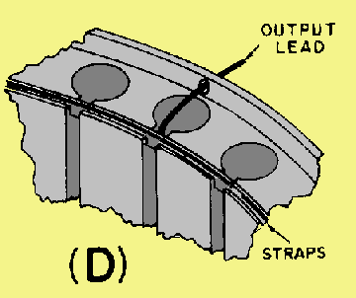
Strap-fed loop method- intercepts the energy between the strap and the segment
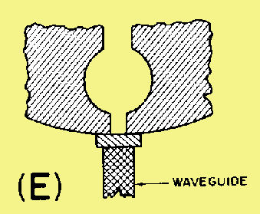
Aperture, or slot, coupling- Energy is coupled directly to a waveguide through an iris
MAGNETRON TUNING
A tunable magnetron permits the system to be operated at a precise frequency anywhere within a band of frequencies, as determined by magnetron characteristics.
The resonant frequency of a magnetron may be changed by varying the inductance or capacitance of the resonant cavities. In figure 2-36, an inductive tuning element is inserted into the hole portion of the hole-and-slot cavities. It changes the inductance of the resonant circuits by altering the ratio of surface area to cavity volume in a high-current region. The type of tuner illustrated in figure 2-36 is called a SPROCKET TUNER or CROWN-OF-THORNS TUNER. All of its tuning elements are attached to a frame which is positioned by a flexible bellows arrangement. The insertion of the tuning elements into each anode hole decreases the inductance of the cavity and therefore increases the resonant frequency. One of the limitations of inductive tuning is that it lowers the unloaded Q of the cavities and therefore reduces the efficiency of the tube.
Figure 2-36. - Inductive magnetron tuning.
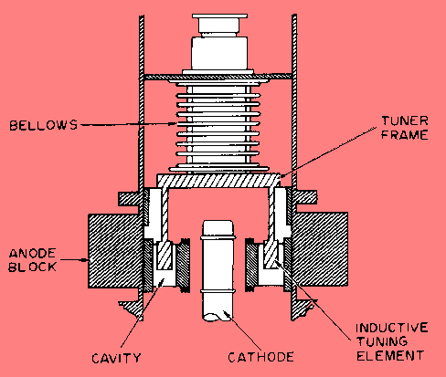
The insertion of an element (ring) into the cavity slot, as shown in figure 2-37, increases the slot capacitance and decreases the resonant frequency. Because the gap is narrowed in width, the breakdown voltage is lowered. Therefore, capacitively tuned magnetrons must be operated with low voltages and at low-power outputs. The type of capacitive tuner illustrated in figure 2-37 is called a COOKIE-CUTTER TUNER. It consists of a metal ring inserted between the two rings of a double-strapped magnetron, which serves to increase the strap capacitance. Because of the mechanical and voltage breakdown problems associated with the cookie-cutter tuner, it is more suitable for use at longer wavelengths. Both the capacitance and inductance tuners described are symmetrical; that is, each cavity is affected in the same manner, and the pi mode is preserved.
Figure 2-37. - Capacitive magnetron tuning.

A 10-percent frequency range may be obtained with either of the two tuning methods described above. Also, the two tuning methods may be used in combination to cover a larger tuning range than is possible with either one alone.
ARCING IN MAGNETRONS. - During initial operation a high-powered magnetron arcs from cathode to plate and must be properly BROKEN IN or BAKED IN. Actually, arcing in magnetrons is very common. It occurs with a new tube or following long periods of idleness.
One of the prime causes of arcing is the release of gas from tube elements during idle periods. Arcing may also be caused by the presence of sharp surfaces within the tube, mode shifting, and by drawing excessive current. While the cathode can withstand considerable arcing for short periods of time, continued arcing will shorten the life of the magnetron and may destroy it entirely. Therefore, each time excessive arcing occurs, the tube must be baked in again until the arcing ceases and the tube is stabilized.
The baking-in procedure is relatively simple. Magnetron voltage is raised from a low value until arcing occurs several times a second. The voltage is left at that value until arcing dies out. Then the voltage is raised further until arcing again occurs and is left at that value until the arcing again ceases. Whenever the arcing becomes very violent and resembles a continuous arc, the applied voltage is excessive and should be reduced to permit the magnetron to recover. When normal rated voltage is reached and the magnetron remains stable at the rated current, the baking-in is complete. A good maintenance practice is to bake-in magnetrons left idle in the equipment or those used as spares when long periods of nonoperating time have accumulated.
The preceding information is general in nature. The recommended times and procedures in the technical manuals for the equipment should be followed when baking-in a specific type magnetron.
The Crossed-Field Amplifier (Amplitron)
The CROSSED-FIELD AMPLIFIER (cfa), commonly known as an AMPLITRON and sometimes referred to as a PLATINOTRON, is a broadband microwave amplifier that can also be used as an oscillator. The cfa is similar in operation to the magnetron and is capable of providing relatively large amounts of power with high efficiency. The bandwidth of the cfa, at any given instant, is approximately plus or minus 5 percent of the rated center frequency. Any incoming signals within this bandwidth are amplified. Peak power levels of many megawatts and average power levels of tens of kilowatts average are, with efficiency ratings in excess of 70 percent, possible with crossed-field amplifiers.
Because of the desirable characteristics of wide bandwidth, high efficiency, and the ability to handle large amounts of power, the cfa is used in many applications in microwave electronic systems. This high efficiency has made the cfa useful for space-telemetry applications, and the high power and stability have made it useful in high-energy, linear atomic accelerators. When used as the intermediate or final stage in high-power radar systems, all of the advantages of the cfa are used.
Since the cfa operates in a manner so similar to the magnetron, the detailed theory is not presented in this module. Detailed information of cfa operation is available in NAVSHIPS 0967-443-2230, Handling, Installation and Operation of Crossed-Field Amplifiers. As mentioned earlier, crossed-field amplifiers are commonly called Amplitrons. You should note, however, that Amplitron is a trademark of the Raytheon Manufacturing Company for the Raytheon line of crossed-field amplifiers. An illustration of a crossed-field amplifier is shown in figure 2-38.
Figure 2-38. - Crossed-field amplifier (Amplitron).
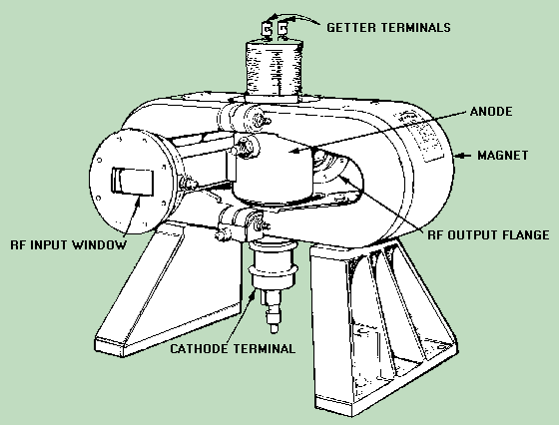

REVIEW QUESTIONS AND ANSWERS
Q.44 Why is the pi mode the most commonly used magnetron mode of operation?
A44. Greater power output.
Q.45. What two methods are used to couple energy into and out of magnetrons?
A45. Loops and slots.
Q.46. Magnetron tuning by altering the surface-to-volume ratio of the hole portion of a hole-and-slot cavity is what type of tuning?
A46. Inductive.
Q.47. Capacitive tuning by inserting a ring into the cavity slot of a magnetron is accomplished by what type of tuning mechanism?
A47. A cookie-cutter tuner.

